The Garden Gate, L.L.C.
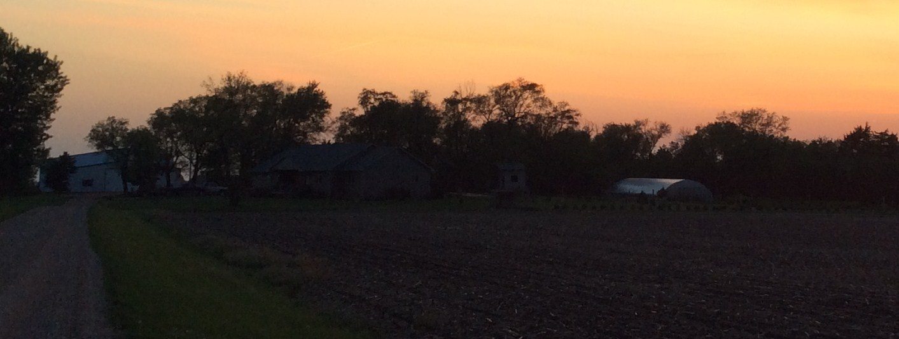

What is a CSA share?
A Community-Supported Agriculture (CSA) share is a weekly variety of fresh fruits and vegetables, locally grown and distributed. Shares are purchased prior to the beginning of the growing season and produce is delivered weekly throughout the season to its members. This year, The Garden Gate will begin its CSA program, beginning in late June and running for 19 weeks. Each week’s share will consist of 7-12 varieties of fruits and vegetables, weighing approximately 10-20 lbs. Here are some of the items that you can expect to see in your share:
Early season - lettuce, spinach, beets, carrots, peas, Swiss chard, kohlrabi, cucumbers, and kale.
Mid-season - beans, sweet corn, tomatoes, potatoes, summer squash, watermelons, cantaloupe, eggplant, onions, cauliflower, broccoli, and cabbage.
Late season - winter squash, onions, peppers, pumpkins, leeks, and raspberries.
Due to the unpredictable nature of the weather, we cannot guarantee that you will receive every item listed, but we will work hard to provide you with a wide variety of crops in every box. If there is a fruit or vegetable that you do not like or that someone in your family is allergic to, we will have an extra box of share available at the pick-up stand for you to switch out for something else. If there is a total crop failure due to weather, we will try to source produce from other reputable growers.
By buying a share in our CSA, you are supporting a local grower as well as getting the peace of mind that you know where your food came from and how it was grown. Your produce will be picked the morning of your delivery whenever possible to ensure freshness. If you would like to visit the farm to see where your food is being grown, just call us!
Your share will be available for pick-up from the Yankton Farmer’s Market on Wednesdays between 4 and 7 pm. Only a limited number of shares are available, so be sure to sign up soon! Please complete and sign our Purchase Agreement on the following page, and return with your check.

The Garden Gate, LLC
Purchase Agreement
The Garden Gate, LLC is a family-owned produce business near Yankton, SD. We strive to provide you with the freshest produce available using all natural, chemical-free practices. By purchasing a share in our farm, you are supporting a local farmer in addition to receiving a weekly share of vegetables that are ready for harvest. The 2015 season will consist of 19 weeks, with pickup available for your share for 18 weeks. This allows you to skip one week at any time throughout the season if you are out of town or cannot pick up your share for any reason.
As a member of our CSA, you partake in the risk as well as the reward of farming. We will do our best to provide you with a bountiful harvest each week, but environmental risks such as drought, hail, and insects may adversely impact the produce for your share. Your investment in our farm helps us to prepare for these risks and we are committed to making sure each customer is satisfied with their share.
You are responsible for picking up your share at the Yankton farmer’s market on Wednesdays from 4-7pm. It is located at the Yankton mall parking lot, south side. (By 21st Street and Fryin Pan)

Name: _________________________________________
Address: _______________________________________
_______________________________________
_______________________________________
Phone: ________________________________________
Email: ________________________________________
(We will try to email weekly updates and reminders to pick up your share, and also email a receipt confirming your order within 2 weeks.)

I understand the terms and conditions of this agreement and acknowledge that The Garden Gate, LLC will not provide a refund in the event that environmental factors impact the quality of produce received.

_____________________________________________ ______________
(Signature) (Date)
Please complete this form and return with a check for $360 payable to The Garden Gate, LLC.
30723 444th Ave.
Mission Hill, SD 57046

